- Component Failure Rate Data
This appendix contains failure rate data for selected electronic components in support of Chapter 8. The information was abstracted from the Military Handbook for Reliability Prediction [MIL-HDBK-217F] and contains information for devices that are relevant to this book. The information is a close facsimile to MIL-HDBK-217F, but in some instances comments are added to help interpret the information. Furthermore, MIL-HDBK-217F tends to present both empirical estimation formulas and tabular data computed from the formulas. The tabular data is generally not included here for simplicity of presentation, and is readily obtained from the formulas supplied. Data is presented for the following devices:
- Analog components: resistors and capacitors.
- Discrete semiconductors: diodes, bipolar transistors, and field effect transistors.
- Microcircuits: gate/logic arrays and microprocessors.
  - Environmental Use
All of the devices presented in this appendix have an environmental factor that is used to estimate the failure rate. The environmental factors are based on the 14 categories in Table C.1.
Table C.1 Environmental symbols and descriptions taken directly from MIL-HDBK-217F.
Environment | Description
G_{B} – Ground, Benign | Nonmobile, temperature and humidity controlled environments readily accessible to maintenance; includes laboratory instruments and test equipment, medical electronic equipment, business and scientific computer complexes, and missile and support equipment in ground silos.
G_{F} – Ground, Fixed | Moderately controlled environments such as installation in permanent racks with adequate cooling air and possible installation in unheated buildings; includes permanent installation of air traffic control radar and communication facilities.
G_{M} – Ground, Mobile | Equipment installed in wheeled or tracked vehicles and equipment manually transported; includes tactical missile ground support equipment, mobile communication equipment, tactical fire direction systems, handheld communications equipment, laser designations and range finders.
Table C.1 Environmental symbols and descriptions taken directly from MIL-HDBK-217F, cont’d.
Environment | Description
N_{S} – Naval, Sheltered | Includes sheltered or below deck conditions on surface ships and equipment installed in submarines.
N_{U} – Naval, Unsheltered | Unprotected surface shipborne equipment exposed to weather conditions and equipment immersed in salt water. Includes sonar equipment and equipment installed on hydrofoil vessels.
A_{IC} – Airborne, Inhabited Cargo | Typical conditions in cargo compartments that can be occupied by an aircrew. Environment extremes of pressure, temperature, shock, and vibration are minimal. Examples include long mission aircraft such as the C130, C5, B52, and C141. This category also applies to inhabited areas in lower performance smaller aircraft such as the T38.
A_{IF} – Airborne, Inhabited Fighter | Same as A_{IC} but installed on high performance aircraft such as fighters and interceptors. Examples include the F15, F16, F111, F/A 18 and A10 aircraft.
A_{UC} - Airborne, Uninhabited Cargo | Environmentally uncontrolled areas that cannot be inhabited by crew during flight. Environmental extremes of pressure, temperature, and shock may be severe. Examples include uninhabited areas of long aircraft such as the C130, C5, B52, and C141. This category also applies to uninhabited areas in lower performance smaller aircraft such as the T38.
A_{UF} - Airborne, Uninhabited Fighter | Same as A_{UC} but installed on high performance aircraft such as fighters and interceptors. Examples include the F15, F16, F111, and A10 aircraft.
A_{RW} – Airborne, Rotary Winged | Equipment installed on helicopters. Applies to both internally and externally mounted equipment such as laser designators, fire control systems, and communications equipment.
S_{F} – Space, Flight | Earth orbital. Approaches benign ground conditions. Vehicle neither under powered flight nor in atmospheric re-entry; includes satellites and shuttles.
M_{F} – Missile, Flight | Conditions related to powered flight of air breathing missiles, cruise missiles, and missiles in unpowered free flight.
M_{L} – Missile, Launch | Severe conditions related to missile launch (air, ground, and sea), space vehicle boost into orbit, and vehicle re-entry and landing by parachute. Also applies to solid rocket motor propulsion powered flight, and torpedo and missile launch from submarines.
C_{L} – Cannon, Launch | Extremely severe conditions related to cannon launching of 155 mm and 5 inch guided projectiles. Conditions apply to the projectile from launch to target impact.
  - Analog Components: Resistors and Capacitors
This section contains failure rate data for resistors and capacitors.

Resistors: Fixed Composition, Fixed Film, and Wirewound
The failure rate is given by the following relationship
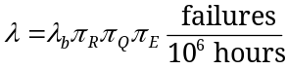.
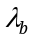 - Base Failure Rate
Resistor Type | 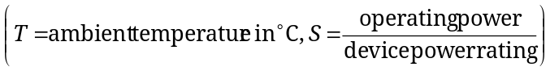
Fixed Composition | 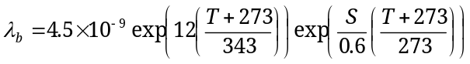
Fixed Film | 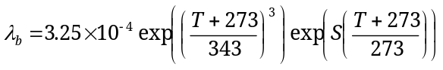
Wirewound | 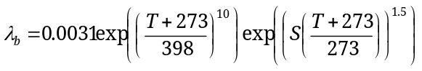
Resistance Factor - 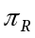
Fixed Composition or Fixed Film Resistors |  | Wirewound Resistors
Resistance Range |  | Resistance Range
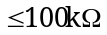 | 1.0 | 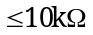 | 1.0
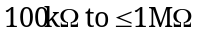 | 1.1 | 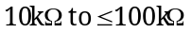 | 1.7
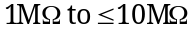 | 1.6 | 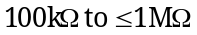 | 3.0
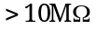 | 2.5 | 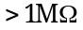 | 5.0

Quality Factor - 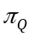
Quality
S | 0.03
R | 0.1
P | 0.3
M | 1.0
MIL-R | 5.0
Lower | 15

Environmental factor - 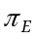
Environment | -  Fixed Composition | -  Fixed Film | -  Wirewound
G_{B} | 1 | 1 | 1
G_{F} | 3 | 2 | 2
G_{M} | 8 | 8 | 11
N_{S} | 5 | 4 | 5
N_{U} | 13 | 14 | 18
A_{IC} | 4 | 4 | 15
A_{IF} | 5 | 8 | 18
A_{UC} | 7 | 10 | 28
A_{UF} | 11 | 18 | 35
A_{RW} | 19 | 19 | 27
S_{F} | 0.50 | 0.20 | 0.80
M_{F} | 11 | 10 | 14
M_{L} | 27 | 28 | 38
C_{L} | 490 | 510 | 610

Capacitors: Fixed, Ceramic, and General Purpose
The failure rate is given by the following relationship
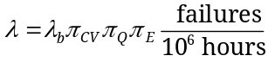 .
For all factors ambient temperature (°C) and 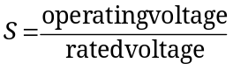, where the operating voltage is the sum of the DC and peak AC voltage.

Base Failure Rate -
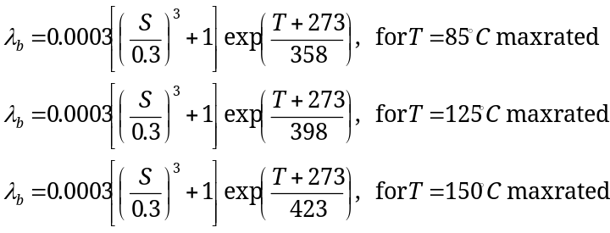

Capacitance Factor - 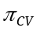  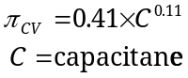  Quality Factor - |  | Environmental Factor -
  Quality
  S | 0.030
  R | 0.10
  P | 0.30
  M | 1.0
  L | 3.0
  MIL | 3.0
  Lower | 10
  Environment
  G_{B} | 1
  G_{F} | 2
  G_{M} | 9
  N_{S} | 5
  N_{U} | 15
  A_{IC} | 4
  A_{IF} | 4
  A_{UC} | 8
  A_{UF} | 12
  A_{RW} | 20
  S_{F} | 0.40
  M_{F} | 13
  M_{L} | 34
  C_{L} | 610

  - Microelectronic Devices
For all microelectronic devices it is necessary to compute the junction temperature (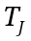) of the silicon in order to determine the temperature factor. The junction temperature is determined as follows:
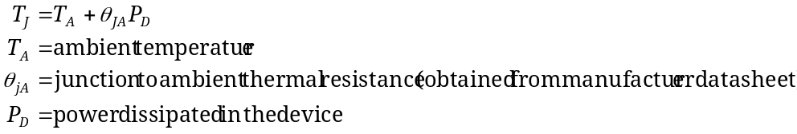

Author’s Note: The equations above are slightly different than those found in MIL-HDBK-217F. The junction to ambient thermal resistance is used here, instead of junction to case as in the original. In addition, the ambient temperature is used in place of the case temperature. This is more general and is consistent with the presentation in Chapter 8. The junction to case resistance could be used, along with the case temperature. See Section 8.2 for more detailed coverage of this thermal model.

The part quality descriptors in Table C.2 are used to find the quality factors.
Table C.2 Part quality descriptors for microelectronic devices.
JANTXV | Full device testing as specified by the MIL-S-19500 specification, including Screening and Groups A, B, and C.
JANTX | Identical to JANTXV, except does not include the 100% precap visual inspection contained in Screening.
JAN | Testing as defined by MIL-S-19500, including Groups A, B, and C, but not including Screening.
Lower | All hermetically packaged devices.
Plastic | All devices encapsulated with organic materials.

Diodes: Low Frequency
The failure rate is given by the following relationship
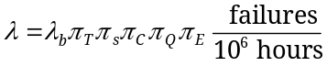.

Base Failure Rate -
Diode Type/Application | 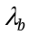
General purpose analog | 0.0038
Switching | 0.0010
Power rectifier, fast recovery | 0.069
Power rectifier, Schottky power diode | 0.0030
Power rectifier with high voltage stacks | 0.0050/Junction
Transient suppressor/varistor | 0.0013
Current regulator | 0.0034
Voltage regulator and voltage reference (avalanche and zener) | 0.0020

Temperature Factor - 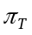
For general purpose analog, switching, fast recovery, power rectifier, and transient suppressor applications
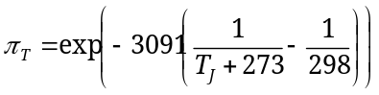.

For voltage regulator, voltage reference, and current regulator applications
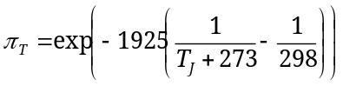.

Electrical Stress Factor - 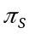  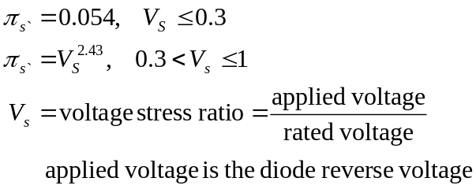  Quality Factor - |  | Contact Construction Factor - 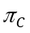  Environmental Factor -
  Quality
  JANTXV | 0.7
  JANTX | 1.0
  JAN | 2.4
  Lower | 5.5
  Plastic | 8.0
  Contact Construction
  Metallurgically bonded | 1.0
  Non-metallurgically bonded and spring loaded contacts | 2.0
  Environment
  G_{B} | 1
  G_{F} | 6
  G_{M} | 9
  N_{S} | 9
  N_{U} | 19
  A_{IC} | 13
  A_{IF} | 29
  A_{UC} | 20
  A_{UF} | 43
  A_{RW} | 24
  S_{F} | 0.50
  M_{F} | 14
  M_{L} | 32
  C_{L} | 320

Diodes: High Frequency (microwave, RF)
The failure rate is given by the following relationship
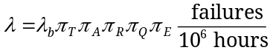.

Base Failure Rate -  Application Factor - 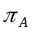  Quality Factor - 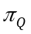 |  | Temperature Factor - 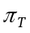  All types except IMPATT  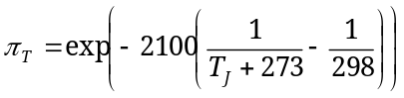,  and for IMPATT  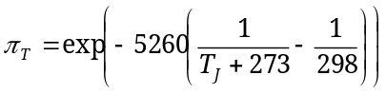.  Power Rating Factor -  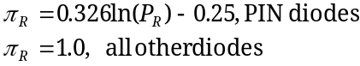  Environmental Factor -
  Diode Type
  Si IMPATT (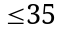GHz) | 0.22
  Gunn/Bulk Effect | 0.18
  Tunnel and Back | 0.0023
  PIN | 0.0081
  Schottky Barrier | 0.027
  Varactor and Step Recovery | 0.0025
  Application | 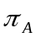
  Varactor, voltage control | 0.50
  Varactor, multiplier | 2.5
  All other diodes | 1.0
  Quality | Not Shottky | Shottky
  JANTXV | 0.5 | 0.5
  JANTX | 1.0 | 1.0
  JAN | 5.0 | 1.8
  Lower | 25.0 | 2.5
  Plastic | 50.0 | -
  Environment
  G_{B} | 1
  G_{F} | 2
  G_{M} | 5
  N_{S} | 4
  N_{U} | 11
  A_{IC} | 4
  A_{IF} | 5
  A_{UC} | 7
  A_{UF} | 12
  A_{RW} | 16
  S_{F} | 0.5
  M_{F} | 9
  M_{L} | 24
  C_{L} | 250

Transistors: Bipolar Junction, Low Frequency (≤ 200MHz)
The failure rate is given by the following relationship
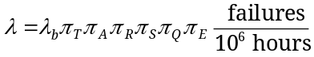.

Base Failure Rate -  Temperature Factor -  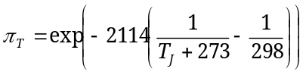  Application Factor -  Power Rating Factor -  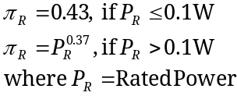  Voltage Stress Factor -  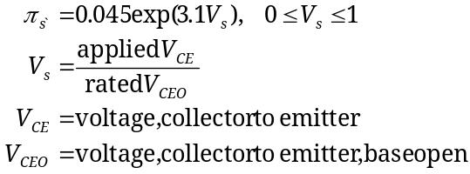 |  | Part Quality Factor -  Environmental Factor -
  Type
  NPN or PNP | 0.00074
  Application
  Linear Amplification | 1.50
  Switching | 0.70
  Quality
  JANTXV | 0.7
  JANTX | 1.0
  JAN | 2.4
  Lower | 5.5
  Plastic | 8.0
  Environment
  G_{B} | 1
  G_{F} | 6
  G_{M} | 9
  N_{S} | 9
  N_{U} | 19
  A_{IC} | 13
  A_{IF} | 29
  A_{UC} | 20
  A_{UF} | 43
  A_{RW} | 24
  S_{F} | 0.50
  M_{F} | 14
  M_{L} | 32
  C_{L} | 320

Transistors: Bipolar Junction, High Frequency (> 200MHz), Low Noise (Power ≤ 1W)
The failure rate is given by the following relationship
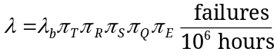.

Base Failure Rate -  Power Rating Factor -  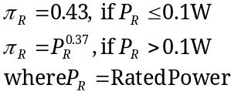  Part Quality Factor - |  | Temperature Factor -  Voltage Stress Factor -  Environmental Factor - 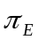
  Type
  All types | 0.18
  Quality
  JANTXV | 0.5
  JANTX | 1.0
  JAN | 2.0
  Lower | 5.0
  Environment
  G_{B} | 1
  G_{F} | 2
  G_{M} | 5
  N_{S} | 4
  N_{U} | 11
  A_{IC} | 4
  A_{IF} | 5
  A_{UC} | 7
  A_{UF} | 12
  A_{RW} | 16
  S_{F} | 0.50
  M_{F} | 9
  M_{L} | 24
  C_{L} | 250

Transistors: Field Effect, Low Frequency (≤ 400MHz)
The failure rate is given by the following relationship
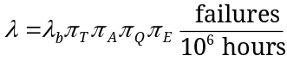.

Base Failure Rate - |  | Temperature Factor -  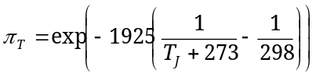
  Type
  MOSFET | 0.012
  JFET | 0.0045

Application Factor - | Part Quality Factor - | Environmental Factor -
  Application (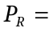rated output power)
  Linear Amplification (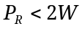)  Small Signal  Switching | 1.50  0.70
  Power FETs  (Non-linear, 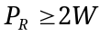)  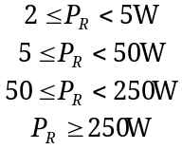 | 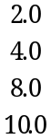
  Quality
  JANTXV | 0.7
  JANTX | 1.0
  JAN | 2.4
  Lower | 5.5
  Plastic | 8.0
  Environment
  G_{B} | 1
  G_{F} | 6
  G_{M} | 9
  N_{S} | 9
  N_{U} | 19
  A_{IC} | 13
  A_{IF} | 29
  A_{UC} | 20
  A_{UF} | 43
  A_{RW} | 24
  S_{F} | 0.50
  M_{F} | 14
  M_{L} | 32
  C_{L} | 320

Transistors: Field Effect, High Frequency (> 400MHz), Low Power (≤ 300mW)
The failure rate is given by the following relationship
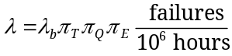.
Base Failure Rate -  Temperature Factor - |  | Part Quality Factor -
  Type
  MOSFET | 0.060
  JFET | 0.023
  Quality
  JANTXV | 0.5
  JANTX | 1.0
  JAN | 2.0
  Lower | 5.0
Environmental Factor -
Environment
G_{B} | 1
G_{F} | 2
G_{M} | 5
N_{S} | 4
N_{U} | 11
A_{IC} | 4
A_{IF} | 5
A_{UC} | 7
A_{UF} | 12
A_{RW} | 16
S_{F} | 0.50
M_{F} | 9
M_{L} | 24
C_{L} | 250

Microcircuits: Gate/Logic Arrays and Microprocessors
Includes the following devices:
- Bipolar devices, Digital and Linear Gate/Logic Arrays
- MOS Devices, Digital and Linear Gate/Logic Arrays
- Field Programmable Logic Array (PLA) and Programmable Array Logic (PAL)
- Microprocessors
The failure rate is given by the following relationship
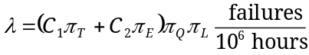 .
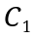 = Complexity Failure Rate for Bipolar Devices (Digital and Linear Gate/Logic)
Digital |  | Linear |  | PLA/PAL
No. Gates |  | No. Transistors |  | No. Gates
1 to 100  101 to 1,000  1,001 to 3,000  3,001 to 10,000  10,001 to 30,000  30,001 to 60,000 | 0.0025  0.0050  0.010  0.020  0.040  0.080 | 1 to 100  101 to 300  301 to 1,000  1,001 to 10,000 | 0.010  0.020  0.040  0.060 | Up to 200  201 to 1,000  1,001 to 5,000 | 0.010  0.021  0.042

= Complexity Failure Rate for MOS Devices (Digital and Linear Gate/Logic)
Digital |  | Linear |  | MOS
No. Gates |  | No. Transistors |  | No. Gates
1 to 100  101 to 1,000  1,001 to 3,000  3,001 to 10,000  10,001 to 30,000  30,001 to 60,000 | 0.010  0.020  0.040  0.080  0.16  0.29 | 1 to 100  101 to 300  301 to 1,000  1,001 to 10,000 | 0.010  0.020  0.040  0.060 | Up to 500  501 to 1,000  1,001 to 5,000  5,001 to 20,000 | 0.00085  0.0017  0.0034  0.0068

= Complexity Failure Rate for Microprocessors
Number of Bits | - Bipolar | - MOS
Up to 8  Up to 16  Up to 32 | 0.060  0.12  0.24 | 0.14  0.28  0.56

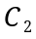 = Package Failure Rate for all microcircuits. 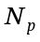 = number of pins on package.
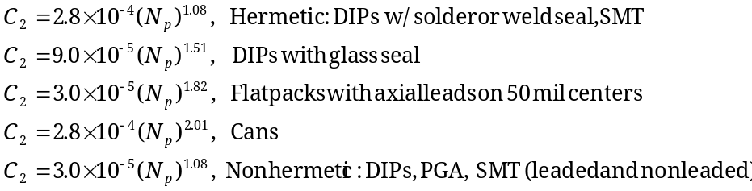

Temperature Factor -
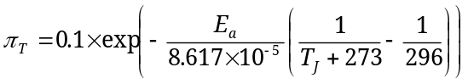

The activation energy (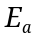) for different technologies are given in the table below.
Technology | TTL, ASTLL, CML, HTTL, FTLL, DTL, ECL, ALSTTL | F, LTTL, STTL | BiCMOS LSTTL | Digital MOS, VHSIC CMOS | Linear (Bipolar and MOS) | Memories (Bipolar and MOS), NMOS
 | 0.4 | 0.45 | 0.5 | 0.35 | 0.65 | 0.6

Learning Factor - 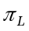 |  | Part Quality Factor -
  Years in Production
  .1 | 2.0
  0.5 | 1.8
  1.0 | 1.5
  1.5 | 1.2
  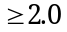 | 1.0
  Quality
  S | 0.25
  B | 1.0
  B-1 | 2.0

Environmental Factor -
Environment
G_{B} | 0.50
G_{F} | 2
G_{M} | 4
N_{S} | 4
N_{U} | 6
A_{IC} | 4
A_{IF} | 5
A_{UC} | 5
A_{UF} | 8
A_{RW} | 8
S_{F} | 0.50
M_{F} | 5
M_{L} | 12
C_{L} | 220

